***DRAFT***

**WMCC Executive Director**

**October 2013**

**Overview**

The purpose of this document is to outline the creation of an Executive Director (E.D.), a new position within the WMCC. The E.D. is a paid staff position dedicated to growing the WMCC’s mission through___. The primary goal of the ED is to_____

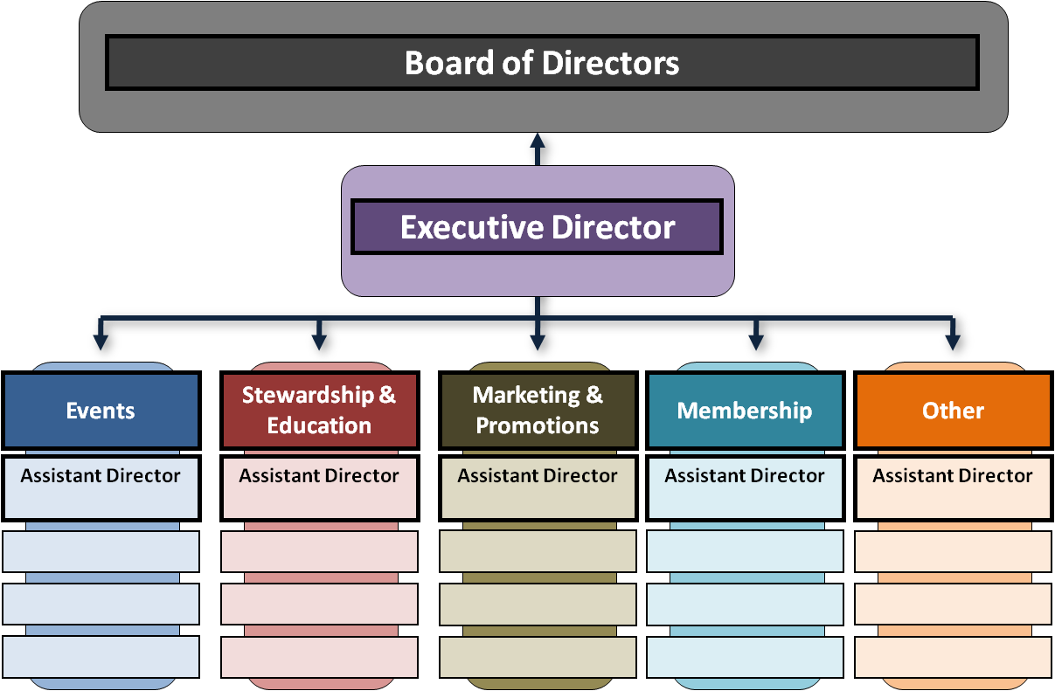**Structure**

The Executive Director oversees volunteer committees and reports directly to the Board of Directors.

**Roles and Responsibilities**

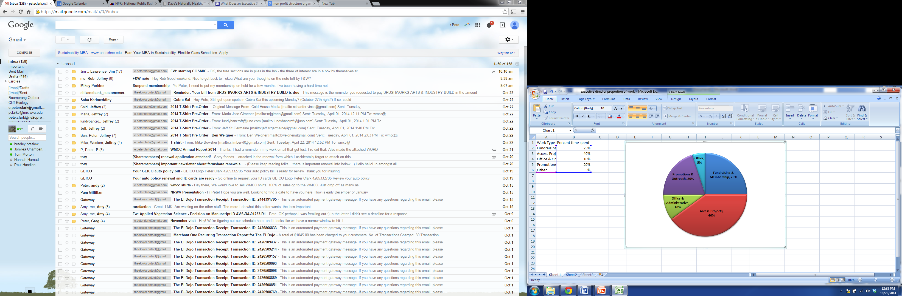The role of the Executive Director is to design, develop and implement strategic plans for the organization in a cost-effective and time-efficient manner. The Executive Director is also responsible for the day-to-day operation of the organization. Specifically, the E.D. will oversee…

The Executive Director will prioritize their time across the following work streams.

*Note, the E.D. is not solely responsible for the development and execution of these streams. They are to provide oversight and regular attention to keep the ball moving.*

* **Access Projects**
  + Pursue new access projects
  + Development of sound management strategies
  + …
* **Fundraising & Membership**
  + …
* **Promotions & Outreach**
  + …
* **Office & Administrative**
  + …
* **Other**
  + …

**Funding and Time Commitment**

For a trial period of 6 months, the E.D. will be a part-time, one 8-10 hour day a week position. $140/day will be allotted (based on a $35k annual salary). The annual cost to the WMCC is $7,000 (tax exempt?).

Possible sources of funding are as follows:

* Joint Membership dues
  + Rely on 100% (currently approximately $2000 annually)
  + Part of responsibility could be gaining members
* Special Events
  + Esselon Silent Auction
    - Rely on 10-20% of profits (~$1000)
  + Rendezvous
    - Rely on 10-20% of profits (~$1000)
  + Boston Silent Auction
    - Rely on 50% of profits (~2,000-$5000)
    - Will need to create this event from scratch
* Grants?
* Access Fund collaboration
  + Northeast Regional Coordinator collaborative position
* Gym partnerships?
  + Sell sponsorship?
  + Provide trainings, clinics, or educational stuff
    - Cliff ecology, gym to crag
* Merchandise?

**Other**

* Are there additional fees and taxes to account for?
* How do we need to restructure organization?